|  |  |
| --- | --- |
| Date | 25 September 2022 |
| Team ID | PNT2022TMID45267 |
| Project Name | Global Sales Data Analytics |

**Sales forecast by order priority**

**What is a Sales Forecast?**

**A sales forecast is a roadmap that guides the company to where it aspires to be. Your sales forecast predicts how much revenue each sales rep, team, or division expects to bring in within a given time period. Sales forecasts use current sales activity data and historical trends to evaluate which deals in your pipeline will close—and at what value—over the course of a quarter, month, or year.**

**To help get you started with sales forecasting, we’ve put together this step-by-step guide. Click the links below to jump to the section. You’ll learn how to think about the critical steps in establishing your forecast, including:**

**•Start with the goals of your forecast**

**•Understand your average sales cycle**

**•Getting buy-in is critical to your forecast**

**•Formalize your sales process**

**•Look at historical data**

**• seasonality**

**Let’s take a look at several different time periods:**

**Weekly: Highly-transactional companies will forecast on a weekly basis.**

**Monthly: For sales cycles that last around 30-60 days, a monthly forecast would work best.**

**Quarterly: Companies with longer sales cycles tend to forecast on a quarterly basis.**

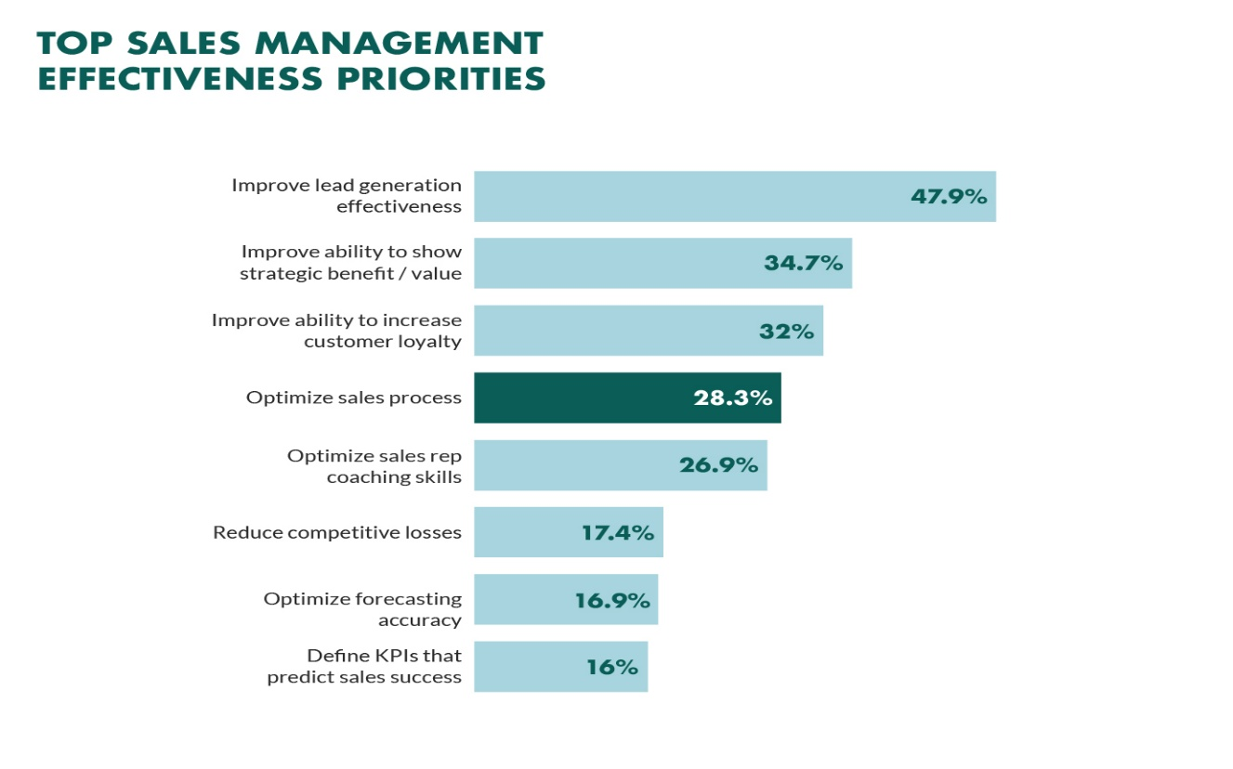

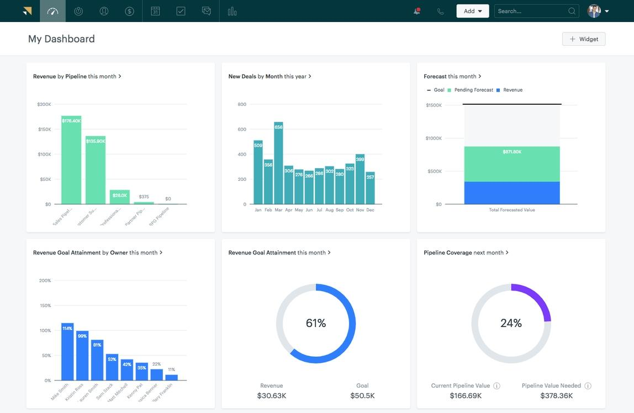

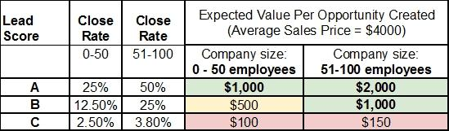

**Sales cycle forecasting As a result, an alternate forecasting method is to use the age of the sales opportunity, rather than the probability, to assess the strength of the pipeline. It compares how long a deal has been in the pipeline, compared to the normal length of time it takes to close a deal. If you have different products, and different sales cycles depending on whether you’ve had a referral or you’re following up a lead from prospecting, then you’ll need to separate those out to get a prediction for how likely a deal is to come off.**